STRATEGIC CHOICE ANALYSIS BY EXPERT PANELS
FOR MIGRATION IMPACT ASSESSMENT

Karima Kourtit and Peter Nijkamp
Faculty of Economics and Business Administration
Department of Spatial Economics
VU University Amsterdam
De Boelelaan 1105
1081 HV Amsterdam
The Netherlands
kkourtit@feweb.vu.nl

Abstract
International migration is a source of policy and research interest in many countries. This paper provides a review of experiences and findings from migration impact assessment worldwide. Various findings are briefly summarized in the context of a systematic migration SWOT analysis for five distinct domains of interest in the economy. The results from each SWOT analysis are then used as an input for compiling a ‘Strategic Choice Matrix’ that is based on the views of a panel of migration experts. These strategic options are interpreted and discussed from both an analytical and a policy perspective.

1. The Age of Migration
We live in the age of migration, and this phenomenon suggests that mankind is structurally ‘on the move’. The age of migration is manifesting itself in various demographic developments and has, inter aliam, led to changes in the population composition of cities in the developed world. Most foreign migrants tend to settle down in the urban areas of the developed world – often in the form of ethnic or language clusters – and create a higher degree of multicultural diversity in many host countries.
Clearly, migration is not a particularly recent phenomenon; it has occurred in all periods of the history of mankind. But the size and geographic scope of current migration are rather unique. Migrant settlement is worldwide but is also predominantly concentrated in specific demographic attraction regions, in particular in the metropolitan agglomerations of the industrialized world. The extent to which foreign migrants exert a positive long-range effect on the local, regional or national economy is, however, still an under-researched area in various countries.
From a global perspective many people are nowadays permanently on the move; international migration has become a key feature of a modern open society (see, e.g., Gorter et al. 1998). According to a widely used definition, migrants are persons who have been outside their country of birth or citizenship for a period of 12 months or longer (Sasse and Thielemann 2005). It is estimated that, at present, there are about 160 million migrants worldwide (2-3 per cent of the world population), supplemented by an estimated 10 million illegal (unregistered or undocumented) migrants (UNHCR, Statistical Yearbook 2003). Europe is also affected by this migration movement. For example, it was estimated that the annual net inflow of migrants into the EU-15 was about 1.7 million in 2002 (Eurostat Yearbook 2004), with just under 50 per cent coming from other European countries. Spain, Italy, Germany and the UK accounted for about 70 per cent of this net inflow. Europe has thus become an important region for international migration with a current stock of 56 million migrants in its population, followed by Asia with 50 million, and North America with 41 million people (Zimmermann 2005).
International migrants come from different countries and form a heterogeneous group (with regard to skills, education, age, gender, welfare position, cultural background, ethnicity, and motivation) that is not evenly distributed over countries or regions, but adopts a self-selected spatial choice and residential location behaviour that leads to culturally-determined socio-geographical networks and spatially concentrated clusters (or niches) in large agglomerations (often in separate urban districts). And therefore, it is no wonder that we observe not only spatially diverse patterns of migrant departures and settlements, but also large differences in the socio-economic impacts of foreign migrants.
The worldwide political and economic turbulence has prompted the emergence of massive population flows moving to other countries, with many positive, but also negative, consequences. It is conceivable that the broad demographic and socio-economic impacts of international migration have in recent decades become a source of deep concern and heated debates among policymakers and the public at large, as well as a source of inspiration for original scientific research (see Bommes and Morawska 2005; Marcura et al. 2005). These are a vast number of research questions related to local socio-economic impact assessment of international migration. Many quantitative research tools have been developed or applied in order to provide a quantitative picture of the impacts of foreign migrants on national or regional welfare or on local labour markets (concerning the latter issue, see e.g., Greenwood et al. 1996; Longhi et al. 2005a, 2005b, 2008; Okkerse 2008). Positive immigration impacts certainly deserve sufficient attention in (urban and regional) economic research.
In light of the previous observations, a burgeoning literature in many countries has emerged over the last two decades to assess the socio-economic impacts of international immigration on host countries. The degree of interest in these issues among various countries differs, however. For example, the Netherlands has been a latecomer in monitoring and assessing systematically such impacts. In the meantime, in many parts of the world much research has been done at the national level under the assumption that impacts in an open system of regions or cities may eventually dissipate through flexible adjustment processes such as labour mobility or broader societal issues (for a general overview, see Gorter et al. 1998). There is, however, also an increasing need to address empirically and systematically the broader and local dimensions of immigration. This is also important, as in many cities in Europe we are faced with negative perceptions – not to say, sometimes a hostile attitude – regarding the externalities inherent in recent rising immigration flows into urban agglomerations.
Over the past few years, the ‘new geography of migration’ has generated various new approaches and insights into the socio-economic effects of migrants, in particular into local/regional labour markets, and into local self-employment (especially ethnic or migrant entrepreneurship). In contrast to the established wisdom that migrants are a source of socio-economic problems, there is a growing strand of the literature which argues that migrants are a source of creative opportunities for the local economy. This idea calls for a novel scientific approach in order to make an empirically valid estimation of the system-wide socio-economic consequences of mass migration for complex local and regional labour markets. This ‘new geography of migration’ thus far does not have a uniform analytical framework, but rather a somewhat fragmented approach, although the preliminary results are promising and fascinating. In this context, the concept of ‘migration impact assessment’ (MIA) could be an important analytical vehicle to map out systematically the pros and cons of international migration.
Against this background, the present paper aims to provide an overview of experiences and findings that address the socio-economic impacts of immigration worldwide, on the basis of a systematic migration impact assessment (MIA) in Section 2. One useful tool to organize a systematic estimation of various immigration effects is a SWOT analysis, specifically differentiated for five distinct domains of socio-economic importance (see Section 3). The results from each SWOT analysis in Section 3 are used as an input for designing a ‘Strategic Choice Matrix’ in Section 4 that is based on the views of a panel of migration experts. And finally, these strategies are interpreted and discussed from both an analytical and a policy perspective, followed by an outline of future research needs, in Section 5.

2. Migration Impact Assessment
2.1 The need for migration impact assessment
Migration is in an open world a ‘natural’ phenomenon. It is plausible that we are entering a new ‘age of migration’. Forced migration (e.g. refugees) calls for humanitarian aid, while voluntary migration (e.g. guest workers, pensionado’s) requires a different perspective. In the developed world, the size of current immigration flows into urban areas, often – but not exclusively – has become a source of public and policy concern and has led to heated debates on the actual or expected impacts of large diverse flows of foreign migrants on the constellation of socio-economic characteristics of cities. A broad societal debate on migration impacts needs a rational and evidence-based foundation in order to trace, monitor and assess the broader economic and societal impacts of immigration on the host country, region or city.
Europe has turned into an immigration region over the course of recent decades. But the migration flows are quite diverse in terms of motives (work, family, asylum, education, retirement, etc.), and in terms of characteristics (nationality/ethnicity, education/skills, gender, age, profession etc.). This variety in migrants leads to great cultural diversity, mainly in urban agglomerations. These far-reaching impacts of rising numbers of foreign migrants call for a systematic and broad-based migration impact assessment system, in which over a long and relevant time period – at least one generation – all relevant socio-economic impacts are estimated. The main aim is not to monetize the economic value of migrants, but to provide an assessment of the socio-economic importance of migration for society, either nationally or locally.
Immigration is usually accompanied by cultural diversity, sometimes also called multiculturalism. This new phenomenon in Europe has prompted many debates on the advantages and disadvantages of cultural diversity. An extensive literature has been published in recent decades on the implications of cultural diversity. It turns out that the empirical studies have generated a long list of positive diversity effects, not only on the labour market but also on many other domains of society. Clearly, there may be significant negative effects (such as crowding-out effects, ghetto effects, or safety effects), but, in fact, the overall balance from empirical studies tends to be highly positive, especially in those areas which attract highly-skilled migrants. In particular, the long-run effects (e.g. in relation to innovativeness, creativity, cultural enrichment, and international orientation) may be significant and positive.

2.2 General findings from migration impact assessment worldwide
Can we assess the socio-economic effects of large flows of immigrants? At the outset it should be clear that migrants exhibit great diversity in terms of demography, geography, culture, language, education, motivation, age and gender. A number of factors, e.g. former colonial links, previous areas of labour recruitment, and ease of entry from neighbouring countries, are responsible for the heterogeneous trends in migration in the past few decades (Stalker 2002).
The diverse migrant flows can be classified into four broad categories of entry: labour migration; family reunification; undocumented workers or illegal immigrants; and asylum seekers. In recent years we also observe also an increasing importance of educational migrants (e.g. students, knowledge workers) and ‘pensionado’s’ in Europe. An assessment of the socio-economic consequences of foreign migrants at the national or regional level has taken place in many countries. Most countries have significant differences in their migration policy history, economic development, and local circumstances. The general findings from various empirical studies in these countries are rather interesting: the popular view that migrant inflows may lead to high crowding-out losses for natives on the labour market (and subsequent wage formation) does not hold. In most cases, these effects are rather small or even negligible. In contrast, studies which adopt a long-range perspective – especially for skilled migrants – tend to find significantly positive effects, depending also, of course, on the specific migration policy adopted in the country concerned. The findings from several applied country studies prompt a more general question, viz. whether it is possible to summarize all the applied quantitative impact modelling studies undertaken so far by means of a meta-analysis, so that a more generally valid proposition on migration impacts can be put forward (see also Longhi et al. 2010).
Various meta-analytic studies have clearly demonstrated that the general fear that a large influx of migrants might generally have a devastating effect on the local or regional labour markets of the host country is not confirmed by empirical facts. In most cases, these effects are negligible to marginal. Further evidence suggests that, if there are crowding-out and competition effects on local labour markets, such phenomena take place among distinct classes of migrants rather than between migrant and natives.
In general, the income effects of migration tend to be significantly positive. Two additional observations have to be made here. First, most meta-analytic studies undertaken do not consider the long-range positive effects on the competitiveness of a region, through which creativity, innovativeness and entrepreneurship – and hence growth – are stimulated. This will undoubtedly have a positive effect on the regional economy (see also Jacobs 1961; Florida 2002). Secondly, apart from effects on regional or local labour markets, there may also be substantial positive effects from the presence of migrant (or ethnic) entrepreneurship (Dana 2007).
In the Anglo-Saxon literature in the past decade, much attention has been given to the economic importance of ethnic (migrant) entrepreneurship. This type of self-employment appears to provide a vital and creative contribution to the urban economy. The increasing size and importance of ethnic entrepreneurship has recently prompted policy and research interest regarding migrant business in Europe. In the Netherlands as well, this new phenomenon is being increasingly recognized and seen as an interesting focus for a city’s SME policy. Ethnic entrepreneurs do not only have a substantial impact on the urban economy but they also act as role models for socio-economic integration. They operate in interesting niches and form a positive stimulus for creative business-making in modern cities.
International migration also has a system-wide effect: migration, international trade and tourism are closely interrelated phenomena. Even though the precise direction and size of causality is still fraught with many uncertainties, it is evident from the literature that there is a clear positive correlation between migration from a country of origin and international trade with the same country. This may create substantial economic advantages for both countries. The same holds for the relationship between migration and tourism, in particular VFR (visits to friends and relatives) (Seetaram 2008). The available information, although sparse, leads to clear evidence of the positive contribution of migration to a country’s tourism sector, and hence to a rise in GDP.
In conclusion, the findings from the literature suggest that migration induces a great variety of positive direct and spillover effects, not only in purely economic terms but also from a broader societal perspective. Clearly, there are evidently negative effects, but experiences worldwide suggest that such effects tend to be mitigated over time, while the intensity of such negative externalities depends critically on the skill levels of migrants and on effective migration policies in the host country. Finally, migration has become a broad, multifaceted phenomenon in our world. The rising tide of migration calls for effective and tailor-made policy initiatives at all levels, so as to meet the challenges and take advantages of the opportunities of the cultural diversity resulting from international migration. Effective policies have to be supported by evidence-based strategic and operational information in order to avoid speculation and prejudices.
As mentioned above, migration means a change in the demographic composition of the host country, accompanied by a wide variety of socio-economic, financial, cultural and societal effects. This calls for a broadly-composed migration impact assessment (MIA), preferably in the form of a SWOT analysis, covering a time horizon of at least one generation. The main question to be addressed then is whether the positive returns on migration that are expected in the long run will compensate for some of the short-term transaction costs over a shorter time horizon. Here, economic arguments can help to lay the empirical foundation for a sound political trade-off.

3. Strategic Choice Analysis (SCA) for Migration Impact Assessment (MIA)
Strategic choice analysis (SCA) provides a systematic framework for analysing the socio-economic importance of migration for society, either nationally or locally. It embodies a number of critical success factors for alternative perspectives in the (urban) economy; and places special emphasis on opportunities for strategic choices and changes (by extending the range of possibilities). In general, SCA can be characterized as: a process of fundamental and genuine strategic choice(s) between different viable options in particular situations and prescriptive views (themes), at the centre of future strategy formulation and implementation, in which decision makers (e.g. responsible representatives, politicians, stakeholders, and other actors) can influence the constellation of socio-economic characteristics of cities worldwide. It is a vehicle for assessing and developing appropriate immigration policies for host countries
The conceptual evaluation framework of the process of choosing viable strategic choice(s) can be systematically divided into six consecutive steps to identify those strategic options and directions that constitute the most effective strategic choices and opportunities, and to evaluate the options against perceived importance categories, with regard to the socio-economic context; starting with the migration impact assessment (MIA) and ending with conclusions and policy recommendations (See Figure 1).
In our application of the framework to the views of a panel of migration experts, we will apply a ‘Strategic Choice Matrix’ (SCM) to evaluate the impact of those explanations and views; and select strategic choice(s) (conforming to the strategic intent), from various feasible and achievable options, that have the highest support and importance classes.
We will now first systematically outline the various steps in our evaluation of the various immigration effects for society, either nationally or locally, specifically differentiated with respect to five distinct domains of socio-economic importance. This can be seen as a toolkit for strategy development for those countries worldwide which aim to take seriously the urgent need for proper data and applied research, in order to encourage an informed discussion on the pros and cons of migration and to induce new realistic perspectives on the future opportunities of international migration. The process of choosing feasible and achievable strategic choices is now presented as in Figure 1.

Step 1. Migration Impact Assessment
Step 2. SWOT Framework for Migration Impact Assessment
Step 3. Assessment of Impacts in Strategic Choice Matrix
Step 5. Performance Analysis of Strategic Choice Matrix
Step 6. Policy Implications and Conclusions
Step 4. Elicitation of Importance Classes in Strategic Choice Matrix

Figure 1. Stepwise presentation of evaluation to identify the most effective strategic choices and opportunities of
various immigration effects

Step 1: Migration Impact Assessment (MIA)
In the first step, we make a short review of recent various empirical studies that address the socio-economic impacts of immigration on host countries, regions or cities on the basis of a systematic migration impact assessment (MIA). This is supported by a summary of the approaches and findings from previous applied empirical studies, often by providing extraits and direct citations from these studies.

Step 2: SWOT framework for Migration Impact Assessment(MIA)
In the second step, to position migration impacts in a broader strategic context of socio-economic benefits, we give a systematic overview of the various effects, preferably in the form of a SWOT (Strength-Weakness Opportunities-Threats) analysis, covering a time horizon of at least one generation, in which past, current and future effects are assessed from a broad perspective.

Step 3: Assessment of impacts in Strategic Choice Matrix (SCM)
In the third step, the most important Strengths (S) and Weaknesses (W) elements, identified in Step 2 from a long-term perspective, are scored for five distinct domains of socio-economic importance in a structured way in an impact matrix, where those socio-economic areas of immigration refer to: labour market, economic development, external effects, cultural diversity, and public effects. During an international workshop ‘KNAW workshop on Migration Impact Assessment’ with representatives from knowledge institutes, universities and policy-making bodies, we asked a group of experts to select and prioritize the most important Strength and Weakness factors for them from a long-term perspective for the five distinct domains of socio-economic importance.

Step 4: Elicitation of Importance Classes in a Strategic Choice Matrix (SCM)
In the fourth step, an important step is the assignment of importance classes to reflect the different order of magnitude of the impact of the most important Strengths (S) and Weaknesses (W) factors that can affect (future) Opportunities (O) and Threats (T), included in the SWOT analysis in Step 2.

Step 5: Analysis of the performance of a Strategic Choice Matrix (SCM)
In the fifth step, we perform the evaluation process, which consists of the application of a multi-criteria evaluation method. We applied Regime analysis, which combines the information contained in the impact matrix and a set of weights to calculate a performance score for each alternative distinct domain of socio-economic importance.

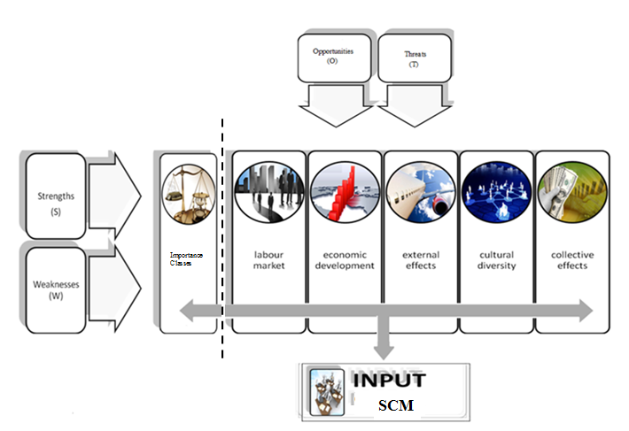
Figure 2. SWOT Input for an SCM

Figure 2 shows the information gathered in the previous steps and the input for the Strategic Choice Matrix (SCM). The Strengths (S) and Weaknesses (W) factors were then ranked according to their preference, given the difference in scores of those factors for each alternative distinct domain of socio-economic importance and the weight of the respective Strengths (S) and Weaknesses (W) factors that can affect (future) Opportunities (O) and Threats (T).

4. SWOT Analyses for Migration Impact Assessment (MIA)
The wealth of literature shows that the impact of migration – in particular, labour migration – on welfare in the receiving and sending countries depends heavily on the flexibility of labour markets. As shown above, the labour market impact of migration has been examined in a large number of qualitative – often econometric – studies in Europe and elsewhere. These studies rely on a cross-section of either regions or branches, and use variations in migrant density in order to identify the impact of migration on wages and employment. The results of these studies show that, on average, migration has only a marginal impact on wages and employment of natives in the receiving countries (see Longhi et al. 2010).
It is noteworthy that many studies also show that migration provides many benefits and contributes to economic growth and the creation of new jobs. Economic growth and the creation of new jobs are strongly associated with the willingness to take up chances across regions, while the supply of jobs regulates the flow of people seeking work. Regional labour mobility in the EU-15 is low: only about 1 out of 200 workers changes residence every year compared with 5 in the United States, in spite of large income differentials within and across these countries (Boeri and Brücker 2005). Hence, immigration from outside the European Union potentially has very crucial role for the creation of a higher level of labour mobility in Europe. If there is labour mobility, it is largely due to international migration (Zimmermann 2005).
Europe is a place where migration is especially useful from an economic perspective. In the context of an ageing population and a need for higher skills, migrants may make an important economic contribution. A study by Boeri and Brücker (2005) shows that international migration can significantly increase income per capita in Europe. They have estimated that, given the wage and productivity gap between Western and Eastern Europe, a migration flow of 3 per cent of the Eastern European population to the West could increase total EU GDP by up to 0.5 per cent. The contributions of migrants to economic growth, and to a wide array of socio-economic benefits, will be examined further in the present section.
It cannot be denied that migration inflows exert a great variety of socio-economic and socio-cultural effects on society. Some of these effects may show up as measurable costs or benefits, others may be characterized by qualitative factors, while yet others may have the features of potential future opportunities and threats which might materialize into measurable impacts at some stage in the future.
To offer a systematic overview of the various effects it is meaningful to use a SWOT (Strength-Weakness Opportunities-Threats) analysis in which past, current and future effects are assessed from a broad socio-economic perspective. This will be provided by means of a systematic analysis, according to five relevant, socio-economic areas of the phenomenon of immigration: namely, labour market, economic development, public sector, cultural diversity, and external effects. The estimated size and weights of these effects are qualitatively identified – on the basis of the information from the previous studies – as: ** strong effect; * moderate effect; o negligible effect; and ? unknown effect. The related SWOT tables may assume the following form (see Tables 1-5).

Table 1: SWOT analysis - Labour Market
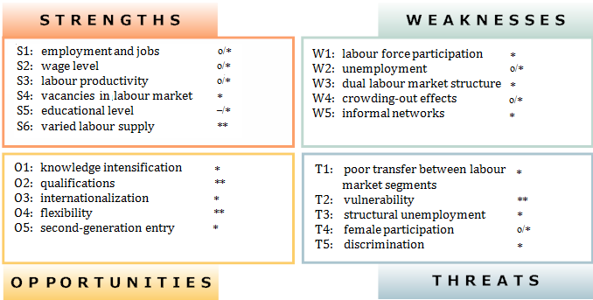

In more general economic terms, the short- and long-term effects of immigration on the labour market, are likely to be positive. It is necessary to catch both the short- and the long-term effects of migration on the labour market, i.e. depending on education level and work motivation and the driving forces of migrants. Compared with the indigenous population, immigrant populations have in common that they are relatively young, and most immigrants of at least 15 years of age are first-generation immigrants, and therefore they can contribute positively to (regional) social-economic vitality.
The possible negative (long-term) effects of such a policy must therefore be weighted for particular target groups for ‘labour market access’ and ‘life-long learning’ for those who have acquired a respected position on the labour market. However, focused and novel scientific research on the relationship between migration and the labour market should be highly weighted in order to define and better achieve empirically valid and reliable general claims.

Table 2: SWOT analysis - Economic Development
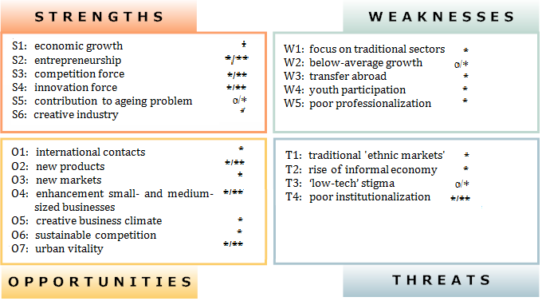

In general, migration is expected to have a favourable effect on economic growth, an assumption that is supported by the theory of international trade and mobility. The findings from various recent empirical country studies have shown that, in general, immigrants are the bridge between their country of origin and host country, and that they have a significant positive effect on the exports and imports of the country where they live (host county).
They foster international trade through their demand for home country outputs, and through their ability to facilitate trade between the host and home countries (e.g. cost differences, product differentiation, migrants’ tastes). Migrant networks are important in this context. Migrants often have a social or business network in their home country which may be used in the host country (e.g. to reduce transaction costs, which may increase both exports and imports).
In addition, greater labour mobility helps to facilitate trade, and increases the cross-border demand for domestic output. The nurturing of cultural diversity may further enhance trade. High-skilled migration, in particular, tends to create a well-educated diaspora who facilitate trade by helping to enforce contracts, act as intermediaries, and expand cooperation (World Bank 2006). In the context of an ageing population and a need for certain skills, migrants may make an important economic contribution. Most migrants are moving from poor countries to rich countries. One cause of this is the globalization process that has enhanced mobility and improved accessibility to different places (Poot et al. 2008).
From our qualitative classification various positive effects are dominant over the negative effects. However, the negative effects are not negligible and require time and, in particular, sufficient attention from the private sector, as well as from the public sector.

Table 3: SWOT analysis - External Effects
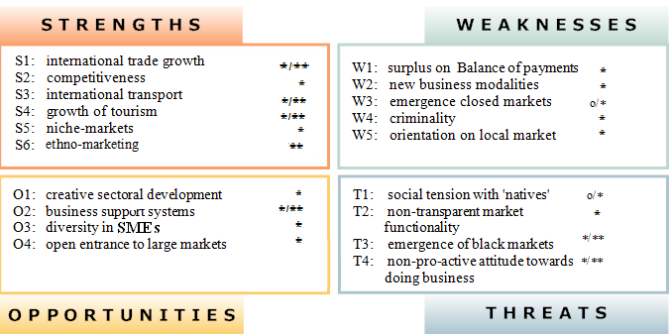

The migration flows are quite diverse in terms of motives and ambitions (labour, family, asylum, education, retirement, etc.), and in terms of ‘pluriformity’ characteristics (nationality/ethnicity, education/skills, gender, age, profession etc.). This variety in migrants leads to great cultural diversity, mainly in urban agglomerations. It can also significantly contribute to the economy by increasing the economic and cultural diversity of a city and reducing unemployment among immigrants. These cities gradually become a multicultural melting pot: a society with people of different cultures, races and religions (Jacobs, 1961, 1969) and a magnet to deliver new ideas for the creative industries and economic growth.
All these migrant categories have different motives and ambitions, and hence their socio-economic impact on a host area differs according to their migration motives. Consequently, a standard uniform MIA that covers all population groups is hard to undertake (see also Fritschi and Jann 2007; Roodenburg et al. 2003).
Sometimes those motives form a rather striking parallel with the socio-economic goals of host regions, and this can cause social-economic tensions, e.g. crowding-out effects, ghetto effects, or safety effects. However, an overall evaluation shows that, in most cases, these effects are rather small or even negligible. In contrast, various empirical studies which adopt a long-range perspective – especially for skilled migrants – tend to find significantly positive effects, depending, of course, also on the specific migration policy adopted in the country concerned.
From this qualitative classification, it appears that, as well as different sectoral and external effects, also various negative effects arise. Those effects need an active effort from the migrants themselves to increase their participation level in Dutch society. Their participation rate in the labour market is on the whole, lower than that of the native population. In addition, certain segments of the immigrant labour force (e.g. women, young people, and elderly workers) encounter specific difficulties in entering the labour market, and hence they are often more exposed to short-term or structural unemployment than the native population. As a result, while their socio-economic progress is significant, it is still not sufficient to reduce the disparities. Therefore, a focussed empirical research study on migration regarding their socio-economic position is essential.

Table 4: SWOT analysis - Cultural Diversity
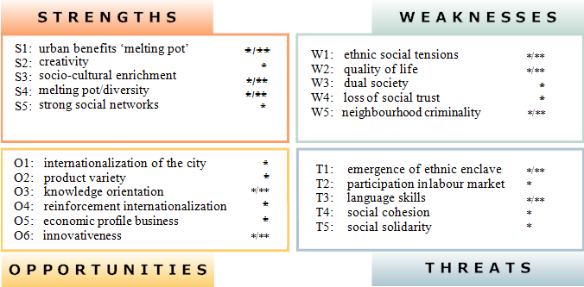

One of the most important challenges facing modern societies is the increase in their social and cultural diversity, often also referred to as integration issues. Cultural diversity has arisen in most advanced countries, driven mostly by sharp increases in immigration. Both the positive and the negative implications of cultural diversity have been addressed by many researchers from different perspectives.
An overall evaluation demonstrates that socio-cultural diversity, rather than uniformity, appears to induce both cultural vitality and economic success. Diversity has a positive effect on creativity, innovation and performance at different scales from company or organization to city, region or country. The reason is that being linked to creative activities is a major source of competitiveness for multicultural cities, as it not only stimulates creative ideas and facilitates creative activities but also assists the cities’ efforts to boost their international profile, attracting investment and a well-educated, creative workforce. Therefore, cultural diversity tends to contribute to the improvement of the creative capacities of cities and regions.
An overall evaluation shows that the negative effects of diversity observed in both the economic and social arena largely depend on individual characteristics such as age, education, and income level. Lower educational attainments, low incomes, and unemployment are associated with the perception of the negative implications of diversity. However, at the country level, diversity is associated with higher productivity and economic growth, and there is no clear evidence that diversity has a negative impact on social cohesion.
From this qualitative classification it appears that cultural diversity serves as an important transformation mechanism for the urban economy. However, significant negative effects are also observed. Therefore, one of the biggest challenges of our ‘age of migration’ is to achieve a balance between the positive and the negative effects, with a focus on realizing a win-win situation. There is, no doubt that more research needs to be done in this area to provide a reliable and systematic overview of those consequences.

Table 5: SWOT analysis – Public Sector
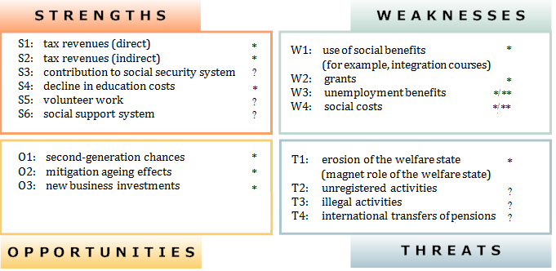
From an economic perspective, it seems reasonable that an estimate of the socio-economic (dis)advantages of significant migration inflows in the public sector requires an accurate analysis of various distinct ethnic groups (Western and non-Western immigrants). This belongs to rational policy analysis, in which systematic impact assessment is a conditio sine qua non.
However, the results of the international literature tend to be short-sighted about the net financial effects of the public sector, because many things depend on labour force participation and the education level of migrants. However, an overall evaluation shows that, in general, immigrants have made a positive contribution to public finance. This is because they have a higher labour force participation rate, pay proportionately more in indirect taxes, and make much lower use of benefits and public services.
All this paints a very positive picture of immigration, one of highly educated, young people, entering into the host country predominantly to work, with subsequent positive contributions to the tax system. This also suggests that the labour market situation of immigrants substantially improves with time in the host country, in terms of both wages and labour force attachment.
Obviously, decision makers (e.g. responsible representatives, politicians, stakeholders and other actors) can calculate which policy effort and initiatives to make regarding specific ethnic groups. However, such calculation tends to be short-sighted, as they neglect the future revenues and (possible) savings which tend to compensate for initial entry costs. It is evident that many costs (e.g. for education) are to be seen as investments for the future.
Any calculation of costs and benefits needs to take account of the time trajectory of the flows of costs and benefits. As in most investment plans, the initial stages are characterized by high entrance costs (directly and indirectly), while at later stages the flows of benefits start to accrue. It is a well-known practice in economic cost-benefit calculations to assume a time period of 20 to 30 years. A shorter time horizon would lead to an overestimation of the costs and an underestimation of social revenues, and would make a cost-benefit analysis futile.
Hence, the information needed for a valid estimation of the system-wide socio-economic consequences of mass migration should not only address the financial and fiscal dimensions of the public sector or the directly measurable economic impacts, but should also address in particular the expected long-range returns and disadvantages, be their monetary or qualitative.
Here too, a focussed empirical research study on migration regarding the migrants’ socio-economic position is essential.
On the basis of the chosen effective SWOT-elements, we now confront the strengths and weaknesses with the opportunities and threats factors in a strategic choice matrix (which is the essence of a SWOT analysis). This is done in order to identify the main strategic points of attention with respect to the several variety of socio-economic and socio-cultural effects of migration on society (see Table 6), which can help to lay an empirical foundation for a sound political trade-off.

5. Strategic Choice Matrix
5.1 Introductory remarks
By means of a ‘Strategic Choice M atrix’ (SCM), a tool that focusses on strategy formulation and undertaken strategic choice(s), it is now useful to determine which are most important Strength and Weakness factors that may affect the opportunities and threats included in the SWOT-analysis. The SCM is used to answer two main questions: 1) What is the most important Strength factor (S) and how can it be used to participate in, or take advantage of, Opportunities (O) (SO strategies) and counter or avoid Threats (T) (ST strategies)?; and 2) What is the most important Weakness factor (W) and can it be eliminated or improved in order to participate in opportunities (O) (WO strategies) and counter or avoid the impact of Threats (T) (WT strategies)?. The answers to these questions can aid in the development of appropriate immigration policies for host countries.
Perniciously, in Section 4 the Strengths (S) and Weaknesses (W) elements for five relevant, socio-economic areas of immigration along with their impact on Opportunities (O) and Threats (T), and scores were presented in Tables 1-5. In addition to the relationship between Strengths, Weaknesses, Opportunities and Threats, the possible quality of policy strategies is now identified by applying appropriate scores and importance classes, which are set in accordance with their perceived impact (see Table 6).
To determine the degree of importance of various scored factors, the rank order ranges from 5=++ (strong impact) to 0=O (no impact); and na= not available. After multiplying each score by its given importance classes, we are able to synthesize all scores to determine the strongest factors for five relevant, socio-economic areas of immigration. This leads us to the conclusion that labour market impacts will always remain critical, but broader productivity and business sector impacts (e.g. competitiveness, innovativeness, SME effects) for the entire economy – either national or local – are equally important, and so are socio-cultural impacts.
Once the relevant factors have been reviewed in order to assess perceived importance categories, strategic choices are then made by selecting those factors that will most greatly influence policy strategies, viz. a combination of Strengths (S) and Weaknesses (W) elements for five relevant, socio-economic areas of immigration along with their impact on Opportunities (O) and Threats (T). All this information can aid in the development of appropriate immigration strategic policies for countries.
The information for the construction of the SCM was provided by 13 experts during the international ‘KNAW workshop on Migration Impact Assessment’ with representatives from knowledge institutes, universities, and policy making bodies. The interview questionnaire was not sent out before the workshop in order to increase the likelihood of spontaneity and unexpected responses in the answers of the experts. This is because the research was more about what experts really experienced in their field and practice than about looking for a correct (theoretical) answer. The main research instrument was our own survey questionnaire. The prioritized or important factors (i.e. those that received the highest scores) are presented in Table 6.

5.2 Design of strategic options and derivation of the key strategies
The results in Table 6 show which are the most important key factors as identified by the expert panel in the process, including both the Strengths (S) and Weaknesses (W) elements. These data indicate the relevant factors of each alternative area or theme, for five relevant, socio-economic areas of immigration along with their impact on the elements Opportunities (O) and Threats (T). Taken together, all this information represents the vital and creative contribution of migration to the urban economy and can aid in the development of appropriate immigration strategic policies for countries.

Table 6: An Integrated Strategic Choice Matrix for MIA
 |  | Absolute  frequency  (f) | Relative  frequency  (%) | Relative  Importance  O | Relative  Importance  T
Labour Market
Strength  factors | S1: employment and jobs | 1 | 8 | 3.00 | 3.00
Strength  factors | S2: wage level | 0 | 0 | na | na
Strength  factors | S3: labour productivity | 6 | 46 | 30.00 | 30.00
Strength  factors | S4: vacancies in labour market | 3 | 23 | 13.00 | 13.00
Strength  factors | S5: educational level | 1 | 8 | 3.00 | 3.00
Strength  factors | S6: varied labour supply | 2 | 15 | 6.00 | 6.00
Strength  factors | Total | 13 | 100
Weakness  factors | W1: labour force participation | 1 | 8 | 5.00 | 5.00
Weakness  factors | W2: unemployment | 7 | 54 | 31.00 | 31.00
Weakness  factors | W3: dual labour market structure | 3 | 23 | 9.00 | 9.00
Weakness  factors | W4: crowding-out effects | 1 | 8 | 3.00 | 3.00
Weakness  factors | W5: informal networks | 1 | 8 | 3.00 | 3.00
Weakness  factors | Total | 13 | 100
Economic Development
Strength  factors | S1: economic growth | 3 | 23 | 13.00 | 13.00
Strength  factors | S2: entrepreneurship | 2 | 15 | 10.00 | 10.00
Strength  factors | S3: competition force | 0 | 0 | na | na
Strength  factors | S4: innovation force | 5 | 38 | 25.00 | 18.00
Strength  factors | S5: contribution to ageing problem | 3 | 23 | 11.00 | 11.00
Strength  factors | S6: creative industries | 0 | 0 | na | na
Strength  factors | Total | 13 | 100
Weakness  factors | W1: focus on traditional sectors | 2 | 15 | 8.00 | 5.00
Weakness  factors | W2: below-average growth | 5 | 38 | 18.00 | 13.75
Weakness  factors | W3: transfer abroad | 0 | 0 | na | na
Weakness  factors | W4: youth participation | 3 | 23 | 11.00 | 11.00
Weakness  factors | W5: poor professionalization | 3 | 23 | 9.00 | 9.00
Weakness  factors | Total | 13 | 100
External Effects
Strength  factors | S1: international trade growth | 5 | 38 | 20.00 | 14.00
Strength  factors | S2: competitiveness | 6 | 46 | 27.60 | 21.60
Strength  factors | S3: international transport | 1 | 8 | 5.00 | 0.00
Strength  factors | S4: growth of tourism | 0 | 0 | na | na
Strength  factors | S5: niche-markets | 1 | 8 | 3.00 | 3.00
Strength  factors | S6: ethno-marketing | 0 | 0 | na | na
Strength  factors | Total | 13 | 100
Weakness  factors | W1: surplus on Balance of payments | 0 | 0 | na | na
Weakness  factors | W2: new business modalities | 1 | 8 | 0.00 | 5.00
Weakness  factors | W3: emergence closed markets | 0 | 0 | na | na
Weakness  factors | W4: criminality | 10 | 77 | 28.00 | 50.00
Weakness  factors | W5: orientation on local market | 2 | 15 | 3.00 | 6.00
Weakness  factors | Total | 13 | 100
Cultural Diversity
Strength  factors | S1: urban benefits ‘melting pot’ | 0 | 0 | na | na
Strength  factors | S2: creativity | 5 | 38 | 25.00 | 20.00
Strength  factors | S3: socio-cultural enrichment | 1 | 8 | 3.00 | 3.00
Strength  factors | S4: melting pot/diversity | 6 | 46 | 24.00 | 23.00
Strength  factors | S5: strong social networks | 1 | 8 | 3.00 | 3.00
Strength  factors | Total | 13 | 100
Weakness  Factors | W1: ethnic social tensions | 4 | 31 | na | na
Weakness  Factors | W2: quality of life | 0 | 0 | 5.00 | 5.00
Weakness  Factors | W3: dual society | 1 | 8 | 21.00 | 26.00
Weakness  Factors | W4: loss of social trust | 6 | 46 | 0.00 | 10.00
Weakness  Factors | W5: neighbourhood criminality | 2 | 15 | na | na
Weakness  Factors | Total | 13 | 100
Public Sector
Strength  factors | S1: tax revenues (direct) | 5 | 38 | 23.00 | 9.00
Strength  factors | S2: tax revenues (indirect) | 0 | 0 | na | na
Strength  factors | S3: contribution to social security system | 6 | 46 | 30.00 | 23.00
Strength  factors | S4: decline in education costs | 1 | 8 | 3.00 | 5.00
Strength  factors | S5: volunteer work | 0 | 0 | na | na
Strength  factors | S6: social support system | 1 | 8 | 5.00 | 5.00
Strength  factors | Total | 13 | 100
Weakness  factors | W1: use of social benefits | 5 | 38 | 16.00 | 21.00
Weakness  factors | W2: grants | 1 | 8 | 3.00 | 3.00
Weakness  factors | W3: unemployment benefits | 3 | 23 | 8.00 | 15.00
Weakness  factors | W4: social costs | 4 | 31 | 16.00 | 20.00
Weakness  factors | Total | 13 | 100

First, we ranked the Strengths and Weaknesses factors from highest to lowest in percentages in each theme, e.g. the percentage scores for labour market are S3:labour productivity 46 per cent; S4: vacancies 23 per cent; S6: varied labour supply 15 per cent; S1:employment and jobs 8 per cent; S5:educational level 8 per cent; S2: wage level 0 per cent. And we then prioritize those with the highest rank, as strategic choices and changes for each theme, as the basis for the formulation and implementation of strategies to influence socio-economic composition of cities worldwide; and which aid in the development of appropriate immigration policies for countries.
The following most promising critical success factors and strategies are identified for five relevant, socio-economic areas of immigration: labour market; economic development; external effects; cultural diversity; and public sector.

Labour market
In the first dominant theme ‘labour market’, by using a weighted average to assess a factor’s impact, it can be concluded from the results of Figure 7 that the most important strength factor is labour productivity (S3) which comes in the first position (46 per cent) with the highest impact on O and T (30.00 and 30.00, respectively), followed by vacancies in the labour market (S4) (23 per cent) also with a strong effect due to the high impact of this factor on O and T (13.00 and 13.00, respectively). The strength factor Wage level (S2) was not chosen (0 per cent) by any experts.
Further, Figure 7 shows that that the most important Weakness factor is unemployment (W2) (54 per cent) with the highest impact on both O and T (31.00 and 31.00, respectively), followed by dual labour market structure (W3) (23 per cent) with a low impact on O and T (9.00 and 9.00, respectively). The Weakness factors crowding-out effects (W4) (8 per cent) and informal networks (W5) (8 per cent) scored worst with the lowest impact on both O and T (3.00; 3.00 and 3.00; 3.00, respectively).
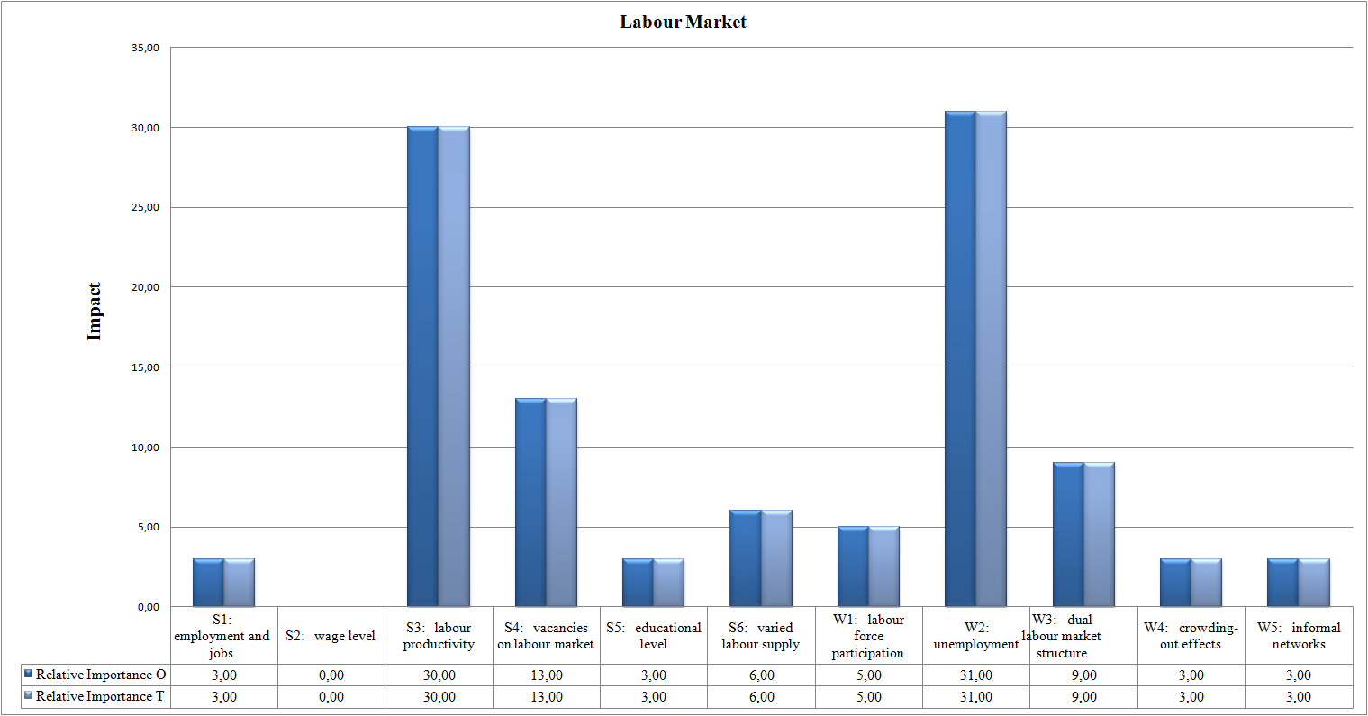
Figure 7: Strength-weakness factors for the labour market
In the first dominant theme ‘labour market’, the following critical success factors and strategies are needed to face the challenge of international migration. They are based on the most important Strength (S) and Weakness (W) points in order to take advantage of (future) opportunities (O), (SO and WO). Serving as a basis for actions and selective (urban) policy activities, these factors and strategies are:
- Improvements in diverse communities’, societies’ and firms’ ability to integrate migrants (e.g. into life and work), and supporting diversity could increase the contribution of migrants’ skills to productivity growth by helping migrants to fully utilize their (specialized) skills in the host countries’ creativity- and innovation-driven new economy, and be more efficient in terms of cultural vitality and economic success.
- Diversity fosters creativity and innovation, contributes to entrepreneurship, enhances productivity, and promotes economic growth. Being linked to creative activities, diversity offers a major source of competitiveness for multicultural cities; and assists the cities’ efforts to boost their international profile, attracting investments and a well-educated, creative workforce. Therefore, including promoting networking with home countries − transaction costs are lowered as immigrants will have knowledge of their home countries’ markets, business practices and laws − and supporting diaspora arrangements for source country development contribute to the improvement of the creative capacities of cities and regions.
- Greater labour mobility helps to facilitate trade and increases the cross-border demand for domestic output. The nurturing of cultural diversity may further enhance trade. However, social cohesion and the accumulation of social capital are not natural outcomes in increasingly diverse societies, but require resources to be allocated to the promotion of desirable social outcomes. Thus, the social evaluation of greater cross-border mobility resulting from greater international economic integration must go hand in hand with the economic assessment.

From a different angle, in the first dominant theme ‘labour market’, the following critical success factors and strategies are needed to face the challenge of international migration. Here, they are based on the most important Strength (S) and Weakness (W) points, in order to avoid or reduce the impact of (future) threats (T), (ST and WT). Serving as a basis for actions and selective (urban) policy activities, these factors and strategies are:
- Create new market opportunities for business entry and the success of ethnic entrepreneurs and stimulate market expansion (viz. ‘breaking out’ and ‘breaking-in’ strategies) to bridge the gaps that exist between the various ethnic entrepreneurs in their local social informal network and (other) formal networks, institutions or groups in host society (on the local, regional and national levels), all of which build confidence and lead to increased awareness, knowledge and trust.
- Expansion strategies will trigger further mobilize immigration, in particular high-skilled professionals who are complementary to investment flows in the sectors in which they are employed, and thus attract more investments.
- New business and market opportunities should be created to stimulate transfer between labour market segments and job creation in host countries for both the native population and certain segments of immigrant labour force (e.g. low-skilled migrants, women, young people, and elderly workers, who are disadvantaged partly due to discrimination and inappropriate access to schooling and training) who encounter specific difficulties in entering the labour market, are often more exposed to short-term or structural unemployment (e.g. lack of ambition, various social problems) than the native population, and experience vulnerability in the labour market. This will also increase productivity.
- Immigrants affect both the supply and the demand side of the local economy from their day of arrival. On the supply side, one or more members of the migrant household are likely to enter the local labour market, which affects the supply of labour with skills and attributes similar to those of the immigrants. The impact on other workers, either native born or earlier immigrants, depends greatly on the extent to which the different types of labour can substitute for each other in production, and the extent to which firms change the composition of output and production methods following an immigration-induced labour supply shock. On the demand side, migrant earnings and/or migrant wealth, and sometimes social security payments, fund the consumption and housing of migrant households.

Economic development
In Figure 8 we present the results for the second dominant theme ‘economic development’, where, in general, innovation force (S4) (38 per cent), economic growth (S1) (23 per cent) and contribution to ageing problem (S5) (23 per cent) achieved the highest scores by experts as the most important strength factors, where S1 has a high impact on O and T (25.00 and 18.00, respectively).The scores gradually get lower for entrepreneurship (S2) (15 per cent), competition force (S3) (0 per cent), and creative industry (S6) (0 per cent); but for entrepreneurship (S2) the impact on O and T is stronger.
Further, Figure 8 shows that below-average growth (W2) scores high (38 per cent) as the most important Weakness factor in this theme with the highest impact on O and T (18.00 and 13.75, respectively), followed by youth participation (W4) (23 per cent) and poor professionalization (W5) (23 per cent), but with a weak impact on both O and T (11.00; 11.00 and 9.00; 9.00, respectively). However, the score become gradually lower for the Weakness factor ‘focus on traditional sectors’ (15 per cent), but with almost no impact on reducing T (8.00 and 5.00, respectively).
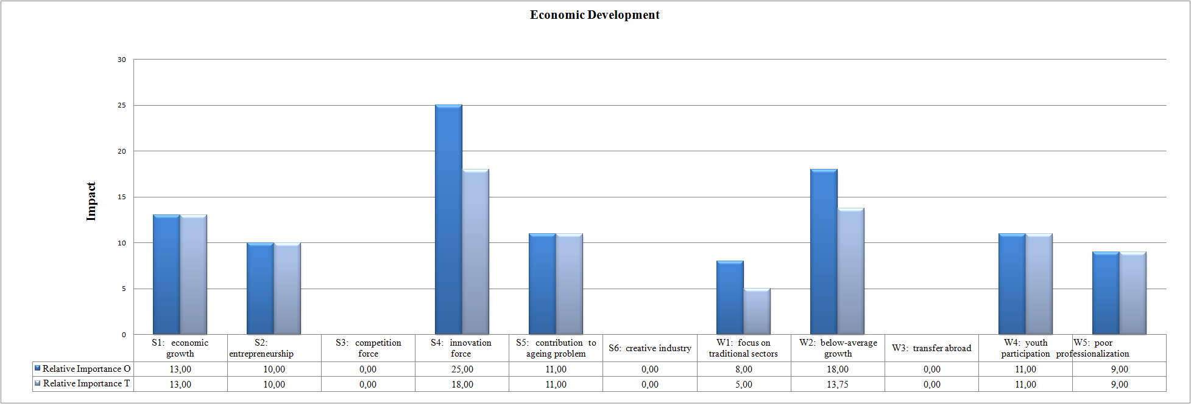
Figure 8: Strength-weakness factors for economic development
In the second document theme ‘economic development’ the following critical success factors and strategies are needed to face the challenge of international migration. They are based on the most important Strength (S) and Weakness (W) points in order to take advantage of (future) opportunities (O), (SO and WO). Serving as a basis for actions and selective (urban) policy activities, these factors and strategies are:
- There is a need to create a new vision where higher diversity can lead to more innovation and creativity. Creativity in general seems to be enhanced by immigration and cultural diversity. Diversity and different conditions in people’s working and living environment stimulates and creates potential benefits by increasing the variety of goods, services and skills available for consumption, production, new ideas, innovation and economic growth.
- An innovative economy will bring cultural, creative and innovative activities into a new focus, which can contribute to the creation of new products and markets, the business climate, a vital urban environment, and economic growth. Creative and innovative activities are often associated with entrepreneurship, where creative and innovative regions can enjoy a high level of dynamic entrepreneurship, so that creativity and innovation offer a positive stimulus for new firm formation in an open and flexible (innovative) economy.

From a different angle, in the first dominant theme ‘economic development’, the following critical success factors and strategies are needed to face the challenge of international migration. Here, they are based on the most important Strength (S) and Weakness (W) points, in order to avoid or reduce the impact of (future) threats (T), (ST and WT). Serving as a basis for actions and selective (urban) policy activities, these factors and strategies are:
- It is important to increase new entrepreneurship in our society: as the necessary condition to create innovations in a competitive economic system; as a provider of new industrial creativity, innovation performance, and technological change; and as a key player for the well-being of local and regional communities.
- New entrepreneurship contributes to the development of integration and great diversity in entrepreneurship in our modern social-economy. Immigrants form a heterogeneous group of people with a wide range of skills, education, innovativeness and business attitude. Migrant entrepreneurs form a significant part of the SME sector in our modern cities, and have become a source of new economic opportunities for regions and cities.
- The innovation force of migrants can help to tackle threats such as ‘traditional ethnic markets’, the rise in the informal economy, low-tech stigma, and poor institutionalization, and, at the same time, it hinders the emergence of these threats. But it should be recognized that in various cases significant barriers still exist (e.g. language and cultural barriers, skill levels, poor professionalization, etc.) that can lead to threats such as below-average growth through the low level of ambition of the low-educated migrant and the indifference of migrants economic growth, which is a danger to urban vitality and to a creative climate.
- Investments in education and training encourage a greater proportion of the work and innovation force of migrants to invest in human capital, thereby generating a positive spillover in the labour market and economic development. It is no secret that the vast majority of migrant entrepreneurs go bankrupt within three years because of underdevelopment and incompetence.

External effects
In Figure 9, we now present the results for the third dominant theme ‘External effects’, where competitiveness (S2) outperforms all other strength factors (46 per cent) with a very high impact on O and T (27.60 and 21.60, respectively), followed by international trade growth (S1) (38 per cent) with a high impact on both O and T ( 20.00 and 14.00, respectively). The remaining variables score worst with no impact on both O and T.
Further, Figure 9 shows that the most important Weakness factor, in the third theme ‘External effects’, is criminality (W4) with the highest score (77 per cent) and a very high impact on O and T. The scores gradually become worse for orientation on local market (W5) (15 per cent), new business modalities (W2) (8 per cent), emergence of closed markets (W3) (0 per cent), and surplus on balance of payments (W1) (0 per cent).
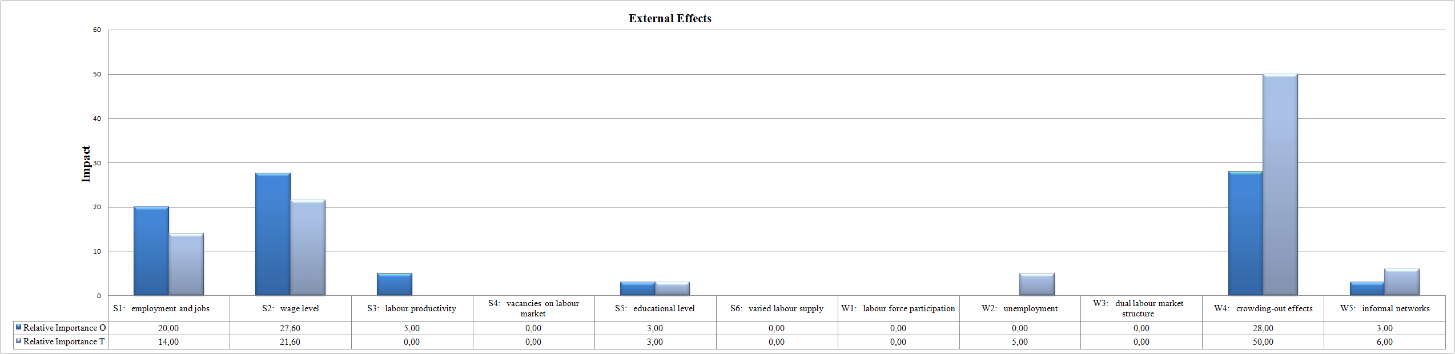
Figure 9: Strength-weakness factors for external effects
In the third document theme ‘external effects’, the following critical success factors and strategies are needed to face the challenge of international migration. They are based on the most important Strength (S) and Weakness (W) points in order to take advantage of (future) opportunities (O), (SO and WO). Serving as a basis for actions and selective (urban) policy activities, these factors and strategies are:
- Cross-fertilization of ideas in a diverse urban environment (Jacobs externalities) creates a contextual environment where more ideas are produced and turned into innovative outputs. Higher competitiveness and availability of knowledge spillovers in a culturally diverse setting contributes to the innovativeness of the host regions. Therefore, the competitiveness of a region should be improved in order to stimulate creativity, innovativeness and entrepreneurship – and hence growth. This will have a positive effect on the regional economy.
- The contribution of immigrants to job creation have not just been limited to ethnic niches and markets, but they can enlarge and expand their market domain through, for example, ‘breaking out’ and ‘breaking-in’ strategies (viz. diversity in SMEs, international trade). These markets are characterized by dynamic competition based on high quality products and services for a broader group of clients and markets outside their own indigenous ethnic group. New trends in migrant entrepreneurship and the migrants’ growth strategies show a rise in second-generation migrant entrepreneurs in business and professional services, Information and Communication Technologies (ICT) and the Creative Industries (CIs) (e.g. creative sectoral development creates possibilities for entrepreneurship and wage moderation) rather than a focus on traditional sectors, where the first generation is operating. Thus, there is a movement from market penetration or product development towards diversification (moving out of the easy part and meeting the challenges) − and this generational change is also contributing to this transformation.

From a different angle, in the third dominant theme ‘external effects’, the following critical success factors and strategies are needed to face the challenge of international migration. Here, they are based on the most important Strength (S) and Weakness (W) points, in order to avoid or reduce the impact of (future) threats (T), (ST and WT). Serving as a basis for actions and selective (urban) policy activities, these factors and strategies are:
- The stimulation of ethnic entrepreneurs has a substantial impact on the urban economy and they also can act as role models for socio-economic integration. They operate in interesting niches and form a positive stimulus for creative business-making in modern cities. As mentioned above, a growing number of second-generation migrant entrepreneurs and an orientation to non-traditional sectors have become the new trends in migrant entrepreneurship.
- More diverse groups have the potential to consider a greater range of perspectives – people with different backgrounds have more diverse and novel ideas, as well as different points of view. And they can also generate more high quality and innovative solutions – in order to solve group conflicts and take all aspects into account. Diversity leads to the confrontation of different ideas, more creativity, and superior solutions to problems.
- The heterogeneous settlements of host cities and regions, with an unprecedented innovative, creative and cultural diversity (with respect to skills, education, age, gender, welfare position, cultural background, ethnicity, and motivation) – which are competitive assets to improve the socio-economic performance of cities and regions – encourage smaller group cohesion, reduce criminality and stimulate high adaptability and help to shape a spectacular new and diverse urban design and lifestyle for accelerated economic growth. On the other hand, criminality, group cohesion and a non-transparent market may: impede the emergence of new firms and entrance to the local markets, isolate (migrant) entrepreneurs; block the efficient functioning of business support systems; lead to high dependency on the welfare state among migrants; and increase social tension with natives.
- Host countries could improve their competitiveness relative to the migrant-sending countries through the devaluation effect on the exchange rate and through the additional spending capacity generated in the migrant-sending countries.

Cultural diversity
Figure 10 presents results for the fourth theme ‘cultural diversity’, where melting pot/diversity (S4) (46 per cent) and creativity (S2) (38 per cent) achieved the highest scores by experts as the most important strength factors, where S4 has the highest impact on reducing T (24.00 and 23.00, respectively). The remaining variables score worst by the experts.
Further, Figure 10 shows that loss of social trust (W4) scores high (46 per cent) as the most important Weakness factor in this theme with a high impact to take advantage of O, followed by the Weakness factor ethnic social tensions (W1) (31 per cent) with a higher impact on T. However, the score and importance become gradually lower for the other factors.
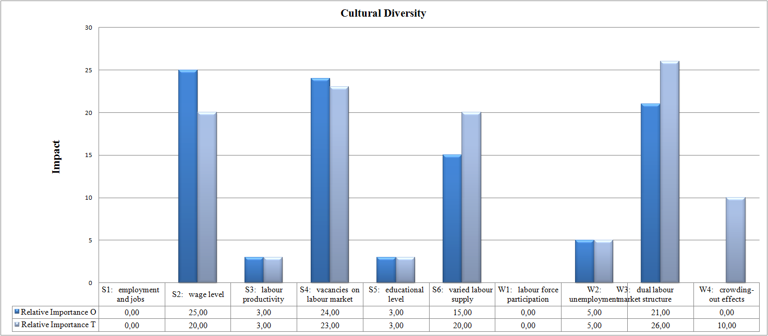Figure 10: Strength-weakness factors for cultural diversity
In the fourth document theme ‘Cultural diversity’, the following critical success factors and strategies are needed to face the challenge of international migration. They are based on the most important Strength (S) and Weakness (W) points in order to take advantage of (future) opportunities (O), (SO and WO). Serving as a basis for actions and selective (urban) policy activities, these factors and strategies are:
- On the regional level, cities can offer by means of their agglomeration advantages (e.g. local identity, an open and attractive urban ‘milieu’ or atmosphere, use of tacit knowledge, the urban embeddedness of new business initiatives, and access to social and financial capital and networks) a broad array of business opportunities for creative cultures. In particular, self-employment opportunities, small and medium-sized enterprises (SMEs) and the internationalization of the city may play a central role in creating new (urban) economic vitality.
- A ‘cultural and socio-ethnic pluriformity’ approach help to determine the various impulses which stimulate many different (high-skilled) ethnic groups to become engaged in the creative industries by deploying urban space as an action platform and mobilizing all resources. This approach can significantly contribute to the economy by increasing the economic and cultural diversity of a city and reducing unemployment among immigrants. These cities have become a multicultural melting pots: societies with people of different cultures, races and religions and a magnet to deliver new ideas for the creative industries and economic growth; and which have a significant positive impact on social cohesion.
- Multiple cultures lead to a better variation in products, innovation and the reinforcement of the internationalization of the city, through the creation of new international (ethnic) networks; greater investment and transfer of technology, knowledge, skills and new ideas via professional immigrants network; which all improve the socio-economic welfare of host countries.

From a different angle, in the fourth dominant theme ‘Cultural diversity’, the following critical success factors and strategies are needed to face the challenge of international migration. Here, they are based on the most important Strength (S) and Weakness (W) points, in order to avoid or reduce the impact of (future) threats (T), (ST and WT). Serving as a basis for actions and selective (urban) policy activities, these factors and strategies are:
- A new orientation on the non-traditional sector with a combination of personal characteristics, skills and experience may produce a very high economic performance and success level of the second-generation entrepreneurs. Therefore, this new orientation may also help them to: escape from ethnic or migrant enclaves (which can cause a language skills problem because the migrants have no incentive to speak the language of host country fluently, erosion of social cohesion, solidarity and trust to tolerate different behaviour, or ghetto formation, all of which create loners in the crowded melting pots); break out from their ethnic dependency; and make more use of, for example, formal networks, formal organizations, governments, financial institutes.
- Moreover, this external orientation may also help them to expand their market into high-volume trade by engaging in trade with indigenous entrepreneurs and other ethnic groups, which contributes to (the regional) business climate and vitality. However, this external orientation does not mean that they will not also continue to benefit from their own ethnic group (enclave economy). Migrant groups who produce a strong entrepreneurial group can be of great economic significance for the migrant business community, as well as for the total community, through job and opportunity creation.

Effects on the Public Sector
Finally, we present in Figure 11 the results for the fifth dominant theme ‘effects on the public sector’, where contribution to the social security system (S3) outperforms all other strength factors (46 per cent) with the highest impact on O and T (30.00 and 23.00, respectively), followed by tax revenues (direct) (S1) (38 per cent) with a strong impact on O and T (23.00 and 9.00, respectively). The scores gradually become lower for the factors decline in education costs (S4) and social support system (S6); with both having a very low impact on O and T.
Further, Figure 11 shows that use of social benefits (for example, integration courses) (W1) and social costs (W4) score the highest (38 and 31 per cent) as the most important Weakness factor in this theme with strong impact on T. The remaining variables score worst.

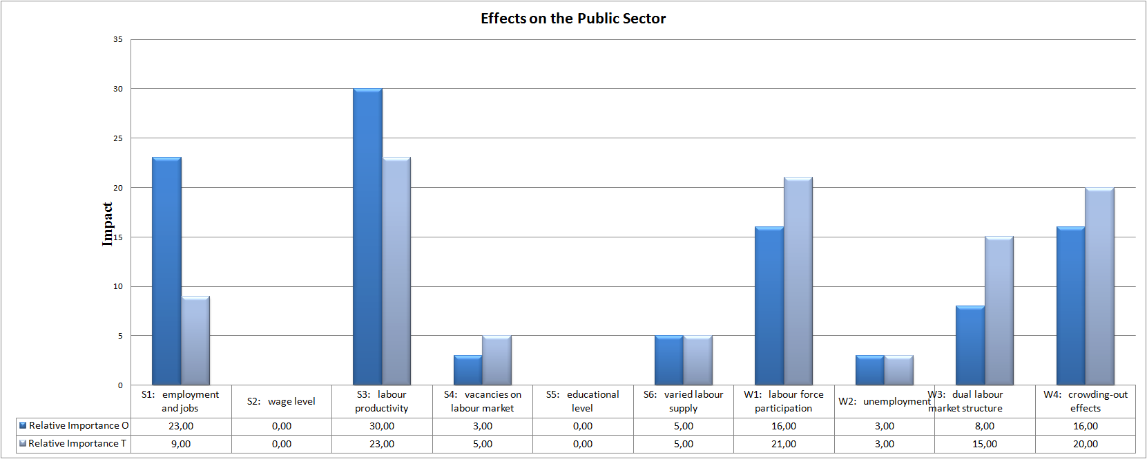
Figure 11: Strength-weakness factors for effects on the public sector
In the fifth document theme ‘effects on the public sector’, the following critical success factors and strategies are needed to face the challenge of international migration. They are based on the most important Strength (S) and Weakness (W) points in order to take advantage of (future) opportunities (O), (SO and WO). Serving as a basis for actions and selective (urban) policy activities, these factors and strategies are:
- A high share of economic migration – implying that immigrants have a speedier access to work – will positively contribute to the Treasury and have a positive influence on population and labour force growth. If natural population growth turns negative, immigration can help maintain a constant level of population and labour force.
- Immigration could remedy shortages of labour and skills that are unrelated to demographic processes. However, immigration is not a solution for tackling the consequences of demographic ageing in Europe. The level of net migration required to keep the old-age dependency ratio constant would entail increases of inflows well beyond socially desirable and politically sustainable levels.
- It is necessary to create and encouraging direct and new (business) investment, foster the business climate, and persuade the private sector to attract migrants of the optimal composition of skill levels in the labour force, e.g. in relation to innovativeness, knowledge intensification, creativity, cultural enrichment, flexibility, diversity, and international orientation, which create challenges for second-generation migrants. All this also vitalizes the labour market, fosters growth and increases demand for unskilled native workers. This also offers a major strategic opportunity to increase the contribution of immigration to productivity, as well as higher demand for goods and services (due to population growth through immigration).

From a different angle, in the fifth dominant theme ‘effects on the public sector’, the following critical success factors and strategies are needed to face the challenge of international migration. Here, they are based on the most important Strength (S) and Weakness (W) points, in order to avoid or reduce the impact of (future) threats (T), (ST and WT). Serving as a basis for actions and selective (urban) policy activities, these factors and strategies are:
- The stimulation of migrant diversity (based on different origin and socio-economic cultural characteristics) makes a positive contribution to public finance and a potentially favourable contribution to welfare of the host regions and countries.
- When highly-educated, young people, enter into host countries predominantly to work they subsequently make positive contributions to the tax system. This is because they have a higher labour force participation rate, pay proportionately more in indirect taxes and social security contributions, and make much less use of benefits and public services.
- Young immigrant workers contribute financially to the social security system (e.g. pensions, social transfer payments), and can significantly increase income per capita and productivity in host countries. However, the net fiscal impact depends substantially on the migrant’s age, education, and the permanency of the stay.
- The coordination of migration policies will have important cross-country spillovers. If one nation closes its borders to migrants, migration flows are diverted disproportionately to other nations, so the other nations react by closing their borders. As a result of this lack of coordination, all host countries can end up with migration restrictions that are higher than is collectively optimal. The cost to host countries for the lack of coordination of migration policies will be high.

6. Conclusions and recommendations
In the Age of Globalization international mobility, closely related to migration, is a ‘normal’ socio-economic phenomenon. Where there is clearly no forced migration (e.g. refugees), migration has a clear socio-economic background in terms of income, wage, and job motives. Therefore, it cannot be ignored that the rising importance of migration worldwide is becoming an important part of our modern economic research. It is clearly a major development in our society, with many positive but also negative consequences involved.
The Netherlands – in contrast to many other countries – does not have a strong tradition in assessing the socio-economic impacts of immigration. However, there is a rich supply of foreign investigations available. These studies contain a variety of questions and methodological tools and techniques, but many of them address these on the basis of a valid systematic migration impact assessment (MIA). From a wide variety of international studies an ‘average irrefutable’ conclusion can be drawn: namely, to date, in general there is no single sufficient piece of empirical evidence for the assumption that migration flow leads to wide variety of negative effects on welfare in host countries.
From a European view, the Netherlands takes average position concerning immigration, with respect to migrant composition and share. It is not inevitable that foreign findings on the socio-economic effects of migration would yield another view for the Netherlands; however it the urgent need for proper data and applied empirical research needs to be taken seriously. Unfortunately, the empirical research on migration effects in the Netherlands is greatly hampered by the lack of appropriate data, particularly at the individual or ethnic group level.
In light of the various perceptions regarding the negative effects of immigration, in recent years a call for a social cost-benefit analysis of migration has been made the Netherlands. Nevertheless, from an economic perspective, it seems reasonable to make an estimate of the socio-economic (dis)advantages of significant migration inflow, if all costs and benefits can be quantified accurately.
Information on the costs of migration, in retrospect, are well known, but there is hardly any information available in the Netherlands on benefits, on the basis of which past, current and future effects can be assessed. Therefore, currently the application of a cost-benefit analysis is not appropriate, because a bias will arise in the estimation and confrontation of cost and benefits. In this context, the concept of ‘MIA’ is a preferable analytical vehicle, in the form of a SWOT analysis that forms a basis for an balanced research programme on the role of migrants by means of the socio-economic impacts on host countries.
A SWOT analysis is not meant to calculate the effects of migration on purely financial grounds, but rather it is used to calculate various socio-economic aspects of migration as far as it is possible for each dimension. Such an analysis systematically follows the confrontation of the strengths and weaknesses with the opportunities and threats factors, whereby past, current and future effects are assessed, in a Strategic Choice Matrix (also the essence of SWOT analysis). This helps both to determine the existing fit of migration in its environment and to devise effective strategies in response to issues in the socio-economic environment; in brief, the matrix indicates what options suit the key issues.
Many international MIA-experiences confirm the general overview that there is no reason to fear that in general a large influx of migrants will generally lead to considerable negative socio-economic consequences for the host country. Rather a significant increase of economic benefits in the long-term, is to be expected depending largely on certain features such as education level, motivation and duration of the stay of migrants.
If the government has a good accommodation policy for migrants, after a certain period of time, a point is reached when significant positive socio-economic effects dominate the negative effects. There is, of course a great variety in the behaviour of migrants and their influence on the national, regional or local economy. However, from many empirical studies undertaken in various countries a general conclusion can be drawn: namely, that immigration does not have an evident negative economic influence on the host country after a certain period of time, certainly if high-skilled migrants are being well-matched on the labour market.
In addition, the fear that migrants are likely take jobs away from ‘natives’ is unjustified. There is hardly any empirical evidence that migration leads to repression and crowding-out effects. On the other hand, a growing strand of the literature argues positively that migrants bring along new skills that have an enriching effect on the local or regional labour market, which improve competition and innovation in a sense relating to this domain. The same applies even more strongly for local entrepreneurship (‘migrants or ethnic entrepreneurship’); and for international trade, infrastructure and tourism.
As mentioned above, migration ,with the exception of forced migration, has a clear social-economic background. Better opportunities and network externalities are offered by large cities. Therefore it comes as no surprise that large cities in the Netherlands have a relative high share of migrants. Those cities are increasingly experiencing the same phenomenon as that in North-America: namely, a ‘melting pot’ of cultures and people. Cultural diversity represents a new challenge and provides opportunities for cities in host countries, and international studies of various cities show that cultural diversity leads to favourable socio-economic conditions where there are complementary labour opportunities or niche-markets. To manage cultural diversity with the focus on the optimalization of constellation of socio-economic characteristics of cities requires the utmost in managerial courage and ability.
This strategic choice analysis has provided a systematic view of the positive and negative social-economic effects of migration for host countries. There is, however, only partial information regarding various effects based upon a rigorous, systematic, scientific analysis of the empirical data. But, for the present, there is no reason to approach the migration phenomenon negatively or hysterically, but what is certain is that solid information is an absolute prerequisite for a reliable and balanced dialogue.

Acknowledgement
The authors wish to thank the participants of the international ‘KNAW workshop on Migration Impact Assessment’ for their useful experiences, comments and views on international migration from a broader perspective in this research study.

References
Boeri, T. and H. Brücker (2005). Why are Europeans so tough on migrants?. Economic Policy, 20(44): 629-703.
Bommes, M. and E. Morawska (eds) (2005). International Migration Research. Ashgate, Aldershot, UK.
Dana L.P. (ed.) (2007). Handbook of Research on Ethnic Minority Entrepreneurship: A Co-evolutionary View on
Resource Management. Cheltenham (UK): Edward Elgar.
Eurostat (2004). Eurostat Yearbook: The Statistical Guide to Europe. Luxembourg: OOPEC.
Florida, R. (2002) The Rise of Creative Class, New York: Basic Books.
Fritschi, T. and B. Jann (2007). Gesellschaftliche Kosten unzureichender Integration von Zuwanderinnen und
Zuwanderern in Deutsland, Güterloh: Bertelsmann Stiftung.
Gorter, C., Nijkamp, P. and Poot, P. (eds) (1998). Crossing Borders. Ashgate, Aldershot, UK.
Greenwood, M.J., Hunt, G.L. and Kohli, U. (1996). The Short-Run and Long-Run Factor-Market Consequences of
Immigration to the United States. Journal of Regional Science 36(1): 43-66.
Hinloopen, E., Nijkamp, P. and Rietveld, P. (1984). The Regime Method; a New Multicriteria Method, in: P.
Hansen (ed.), Essays and Surveys on Multiple Criteria Decision Making. Berlin, Springer, pp. 146-155.
Jacobs, J. (1961). The Death and Life of Great American Cities. New York: Vintage.
Jacobs, J. (1969). The Economy of Cities. New York: Random House.
Longhi, S., Nijkamp P. and Poot, J. (2010). Joint Impacts of Immigration on Wages and Employment: Review and
Meta-analysis, Journal of Geographical Systems, (forthcoming).
Longhi, S., Nijkamp P. and Poot, J. (2005a). The Fallacy of “Job Robbing”: A Meta-Analysis of Estimates of the
Effect of Immigration on Employment. Journal of Migration and Refugee Issues 1(4): 131-152.
Longhi, S., Nijkamp P. and Poot, J. (2005b). A Meta-Analytic Assessment of the Effect of Immigration on Wages.
Journal of Economic Surveys, 19(3): 451-477.
Longhi, S., Nijkamp P. and Poot, J. (2008). Meta-Analysis of Empirical Evidence on the Labour Market Impact of
Immigration. Région et Développement, 27(1): 161-191.
Marcura, M., MacDonald, A.L. and Haug, W. (eds) (2005). The New Demographic Regime. Geneva/New York:
United Nations.
Okkerse, L. (2008). How to Measure Labour Market Effects of Immigration: A Review. Journal of Economic
Surveys, 22(1): 1-30.
Poot, J., Waldorf, B.and Wissen, L. van (eds) (2008). Migration and Human Capital, Cheltenham: Edward Elgar.
Roodenburg, H., Euwals, R. and Pelle, H. ter (2003). Immigration and the Dutch Economy. The Hague: CPB.
Sasse, G. and Thielemann, E. (2005). A Research Agenda for the Study of Migrants and Minorities in Europe.
Journal of Common Market Studies, 43(4): 655-671.
Seetaram, N. (2008). Immigration and tourism demand: evidence from Australia. Unpublished paper presented at
the CAUTHE 2008 Conference, held at Sydney, Australia (11-14 February 2008).
Stalker, P. (2002). Migration Trends and Migration Policy in Europe. International Migration 40(5): 151-179.
UNHCR (2003). Statistical Yearbook: Trends in Displacement, Protection and Solutions. Geneva: United Nations
High Commissioner for Refugees.
World Bank (2006). Global Economic Prospects: Economic Implications of Remittances and Migration,
Washington D.C.: World Bank.
Zimmermann, K.F. (2005). European Labour Mobility: Challenges and Potentials. De Economist, 153(4): 425-450.

